RESOLUTION
El Arc de California

WHEREAS, In order to ensure full, equal, and inclusive opportunities for children and adults with developmental disabilities, Congress enacted the Developmental Disabilities Assistance and Bill of Rights Act, after which the California Legislature enacted the Lanterman Developmental Disabilities Act; and
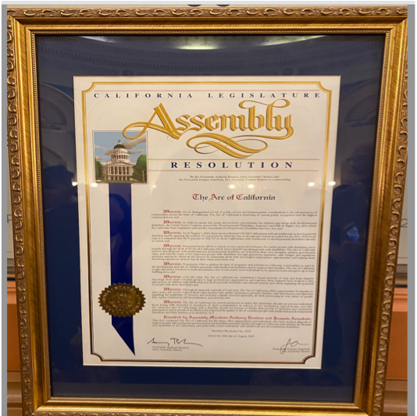
WHEREAS, As of August 1, 2023 there is an estimated 620,000 Californians with an intellectual or developmental disability. Applying the 2021-22 percent of consumers by ethnicity/race at all regional centers, 40.76% or 252,712 of those Californians with intellectual or developmental disabilities identify as Hispanic; and

WHEREAS, The disability community, the general public, and the Legislature is increasingly aware that these disabilities need not prevent individuals from being fully included in school, in the workplace, at home, and as members of their communities; and

WHEREAS, The ethnicity/race of any Californian with a disability should not prevent or hinder their pursuit of inclusion and community participation.

WHEREAS, California recognizes advocates and leaders who have sought access, equity and inclusion for Latinos with disabilities, including El Arc de California and its Coalition members; now, therefore be it

Resolved by the Assembly of the State of California, That the Assembly commends the efforts of the individuals and organizations that have worked diligently to support Californians with developmental disabilities, and celebrates and supports the diversity and capabilities of all our citizens, and particularly those individuals and families who are Latino and experience developmental disabilities;

