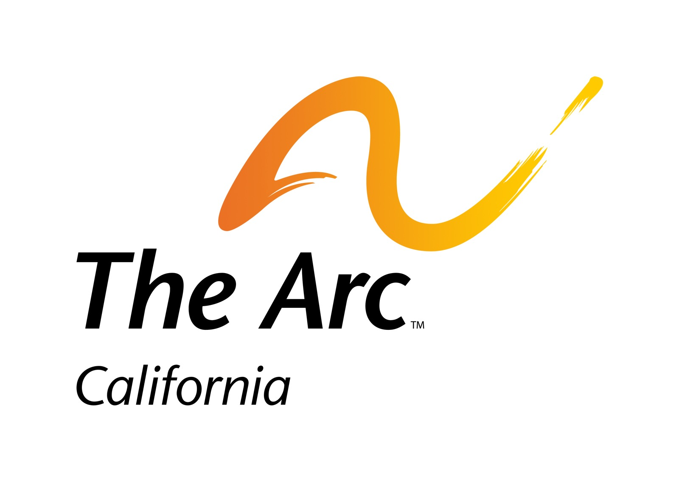
PART-TIME
Administrative Coordinator
Job Description
The Arc of California, the state’s oldest and largest advocacy organization for people with intellectual and developmental disabilities, is seeking a motivated and passionate Administrative Coordinator for our Sacramento office.

Objectives
The Administrative Coordinator’s objectives are:
- Work collaboratively with The Arc CA’s staff and members to advance key policy and society changes that will improve the community of services and supports for Californians with intellectual and developmental disabilities (I/DD).
- Assist to strengthen The Arc CA’s relationships with stakeholders, advocacy partners, media, and state policy makers.
- Enhance The Arc CA’s support for the community through constituent interaction, marketing, fundraising, and outreach efforts.
- Provide support for The Arc CA’s Board of Directors to enable their full participation and leadership for the organization.
- Provide administrative support for the executive director and other directors.

Essential Duties
Working in concert with the The Arc CA’s executive director and other team members, the Administrative Coordinator will:
- Policy & Advocacy: Coordinate with team members to develop assets and launch activities to influence policy, including data research, impact measurements, fact sheets, and grassroots coordination.
- Event Coordination: Manage event coordination process for annual policy conference, Board meetings, fundraisers, and other events, including hotels, event space, logistics, and contracts.
- Program Support: Provide operational & logistical support to projects, including task management, team coordination, and reporting.
- Administrative Assistance: Complete tasks as assigned by executive director or other director staff, including scheduling, research, mailing, copying, and travel arrangements.
- Office Management: Answer and direct phone calls and mail. Be a resource of information for people calling the office. Contribute to an enjoyable and fun work environment.

Requirements
- Proficient in online applications such as Zoom, Google Docs, Canva, and Dropbox.
- Able to manage multiple tasks and self-managing time allocation toward tasks.

Preferred Skills & Experience
- Bilingual in English and Spanish.
- Background in the disability community.
Individuals with disabilities are encouraged to apply.

Location: Sacramento, CA, in-office at least two days per week with options for remote working the other half day.
Starting Wage: $20/hour, 20 hours/week.
Please send a resume and cover letter to Kelli@TheArcCA.org.

